1. In Quote Comments-In Web table- Need to remove empty space

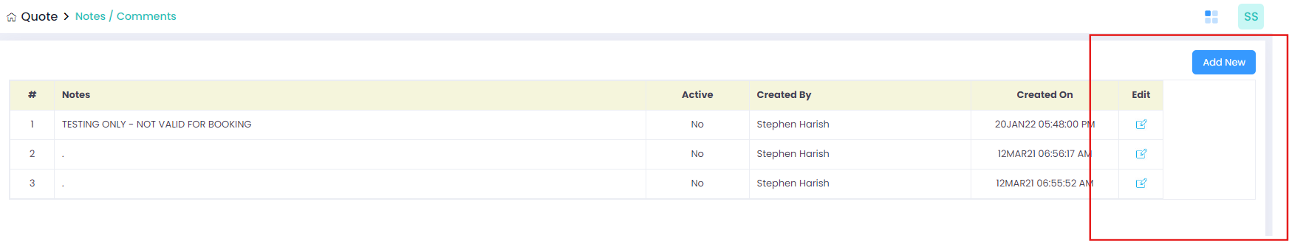

1. In Quote Comments-In Add Airport-Once data get enter and click Add to list button data get saved but pop wont closed.It need to close once data saved
2. In Quote Comments-In Add Customer-Once data get enter and click Add to list button data get saved but pop wont closed.It need to close once data saved
3. In Pricing-Price Rules-In Tail group-After click Choose tail button, once click select all checkbox and click add to list button, data is not added.
4. In Pricing-Price Rules-In Account Type-After click Choose tail button, once click select all checkbox and click add to list button, data is not added.
5. In Pricing-Excel Upload-View History-

* After select the from month and click the search button details displayed improper allignment
* scroll option is also not working
* Download option is also not working

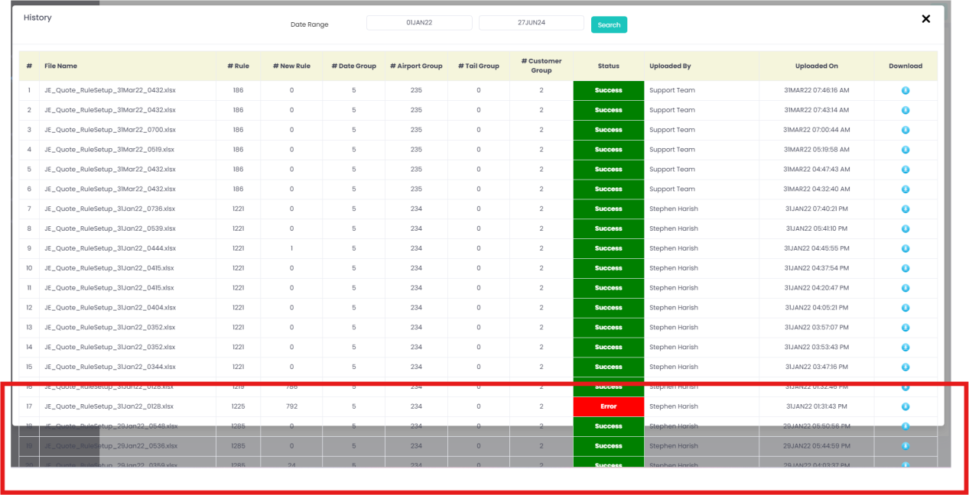

1. In Groups-Ratio Group-Once click the ratio group button, “Un Handled Exception” alert message is dispalyed. And Data cannot able to save.

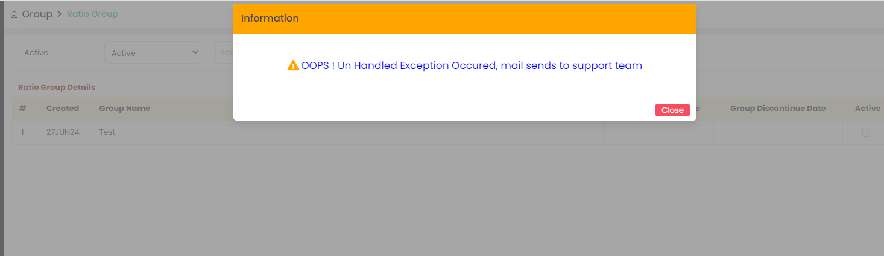

1. In Masters-User Setup-Add New-In User details, without enter any detail and click save button mandatory alert message is not displayed.
2. In Pricing-Excel Upload-”**[Download Validation Rule File](javascript:__doPostBack('ctl00$cpWheelsUp$lnkDwValRuleFile','')" \o "Click here to download the validation Rule File)” button is not working**

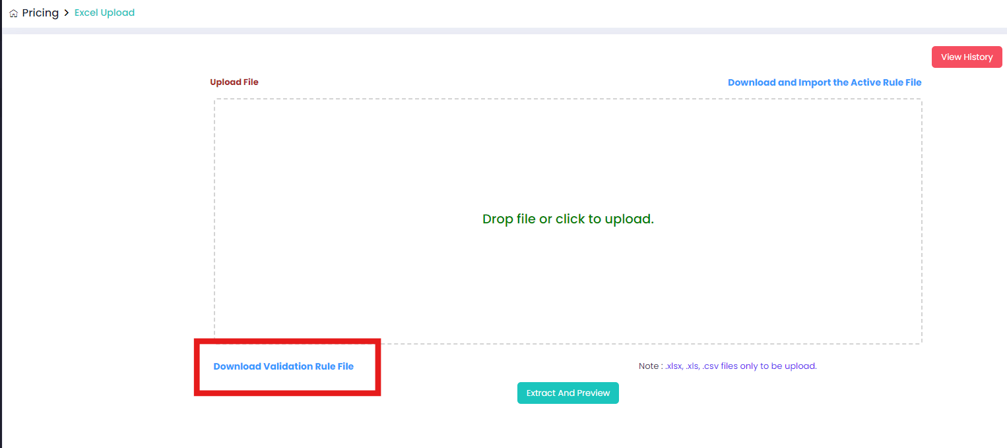

1. Masters-Tax Setup-Click Edit button -Page gets strucked and it wont able to reload properly.
2. Reports-Error Log Report is getting crashed.

12.Wind Temp-Season Setup-once change the season and click clear button its not working. “Clear button is not working”.

13.Quote-Quote list-Click view button-After click expand button in price formula, un handled alert message is displayed.

1. Pricing-Price rules-Once click the copy button in webtable and click copy button unknown alert message is displayed
2. Pricing-price rules-Account type group-After click choose account type button and page shows web table. But in the table un wanted box is displayed.

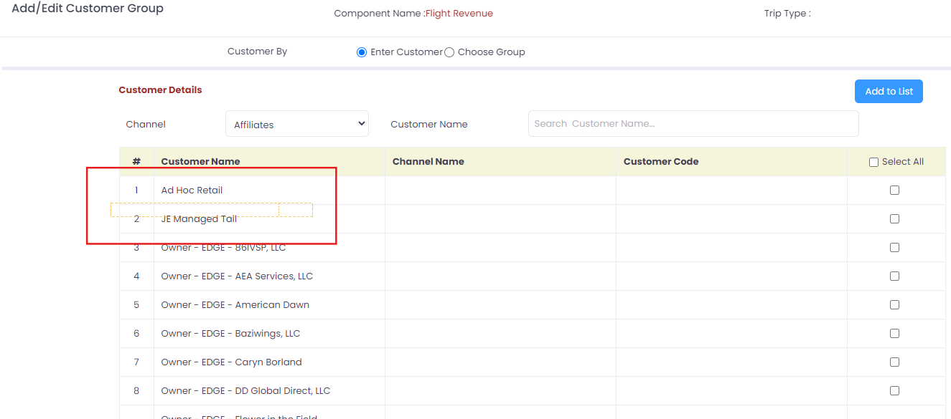

1. Groups-Airport Groups-Add new- When Click group effective date and Group discontinue date two different type of calendar is opened.

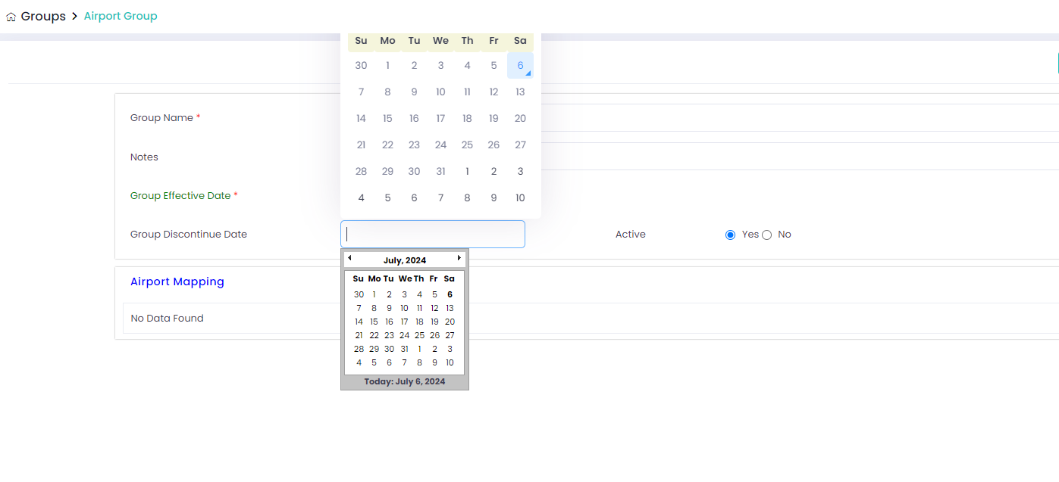

1. Groups-Airport Groups-Add new-After enter valid details and click save button, page shows saved successfully message but in web table saved data is not shown.
2. Masters-Price formula-Add new-When select the airport details and click clear button it won’t clear.

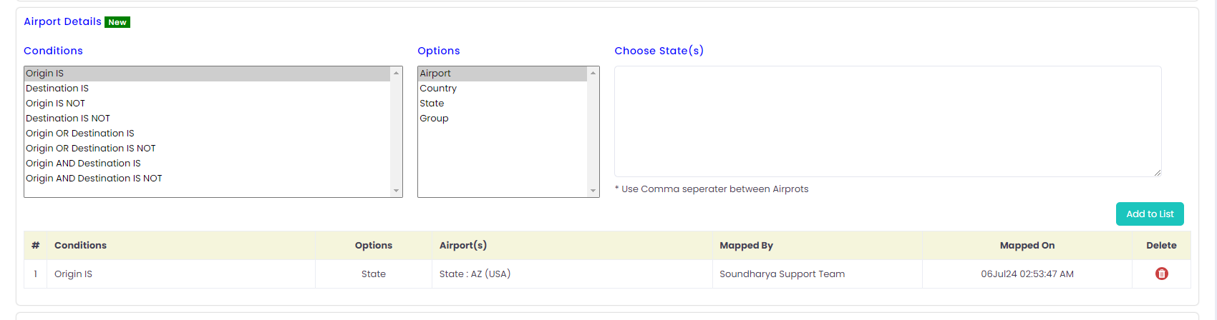

1. Masters-Components-Add new- Component code mandatory symbol is not present.

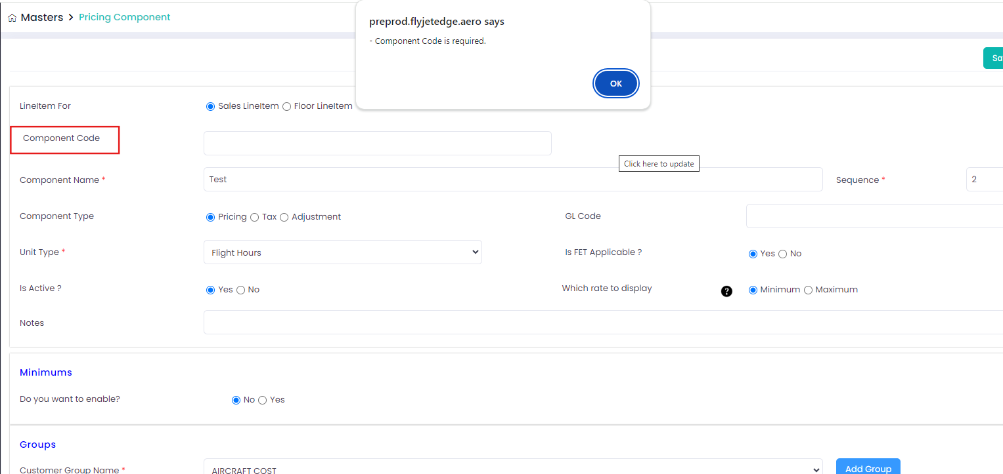

1. Masters-User setup-Add new- Without enter any details and click save and continue button, no mandatory alert message is displayed

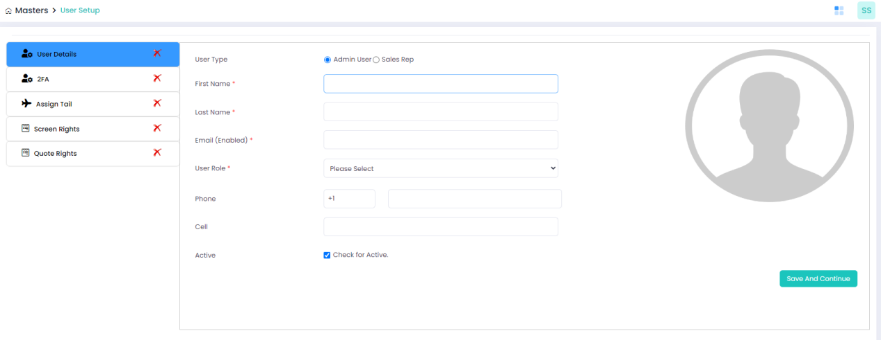

1. Masters-User setup-Add new-When enter valid details in iser details and 2FA tab. After that, select valid assign tail radio button and click submit button, page shows sucessful message but data is not updated and also “X” symbol is not changing.

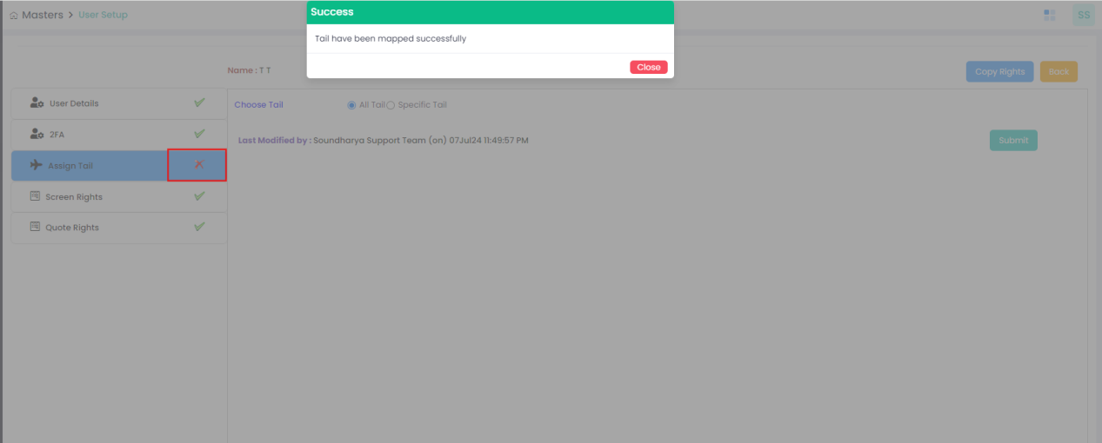

1. Masters-Account-Add new-After enter valid details in account details, In contact details after click add contact button unwanted allert message is displayed.

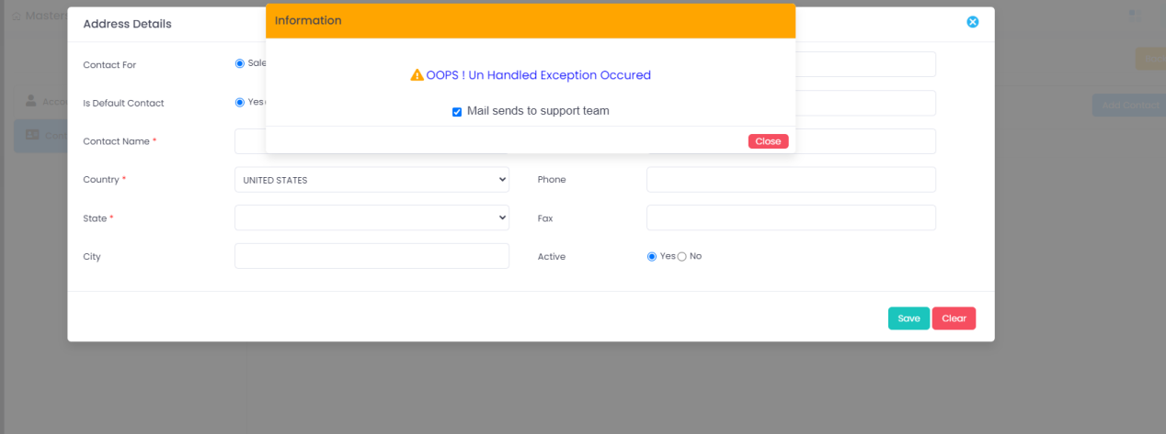

1. Masters-Flight hour setup-

* Click add new button in fore flight API tab, unwanted alert message is displayed
* Click edit button in fore flight API tab, unwanted alert message is displayed

1. Masters-Flight hour setup-In Great circle mapper tab, after click add new button and enter valid details in every field and click save button. Page shows data saved sucessfully but in web table fleet value is empty.

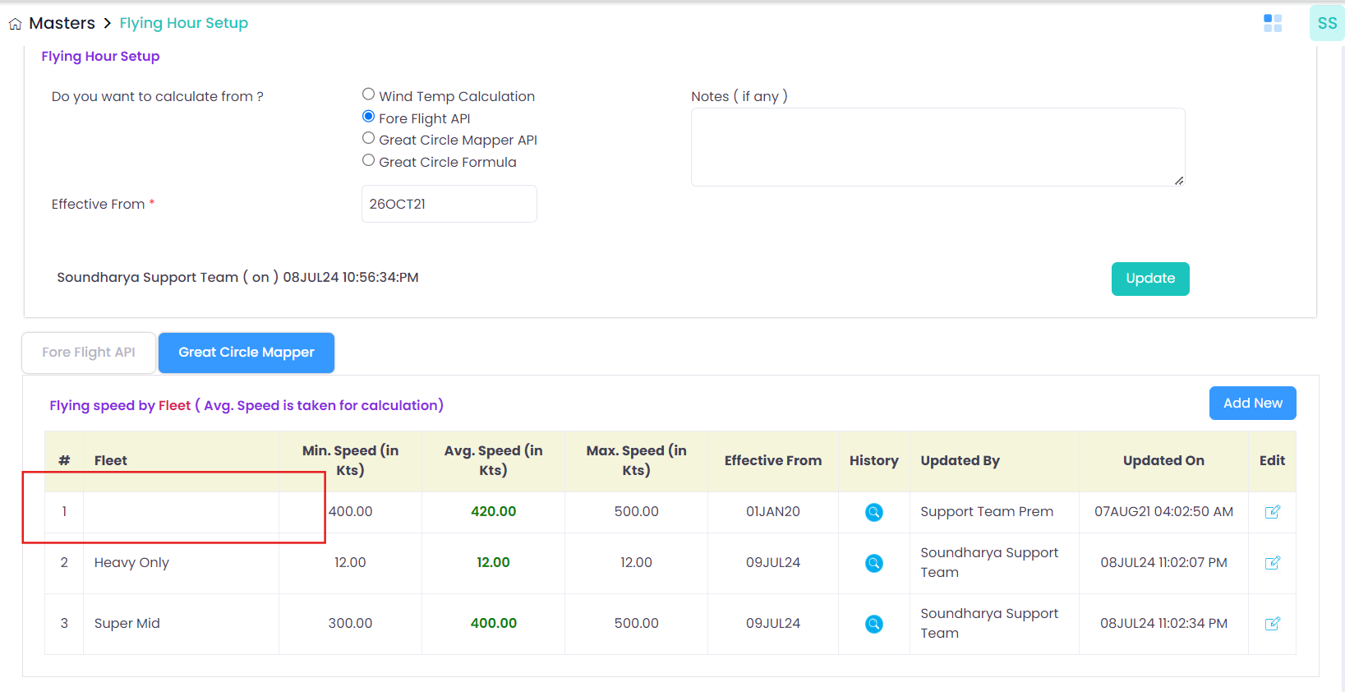

1. Masters-Flight hour setup-In Great circle mapper tab, Delete option is not present.

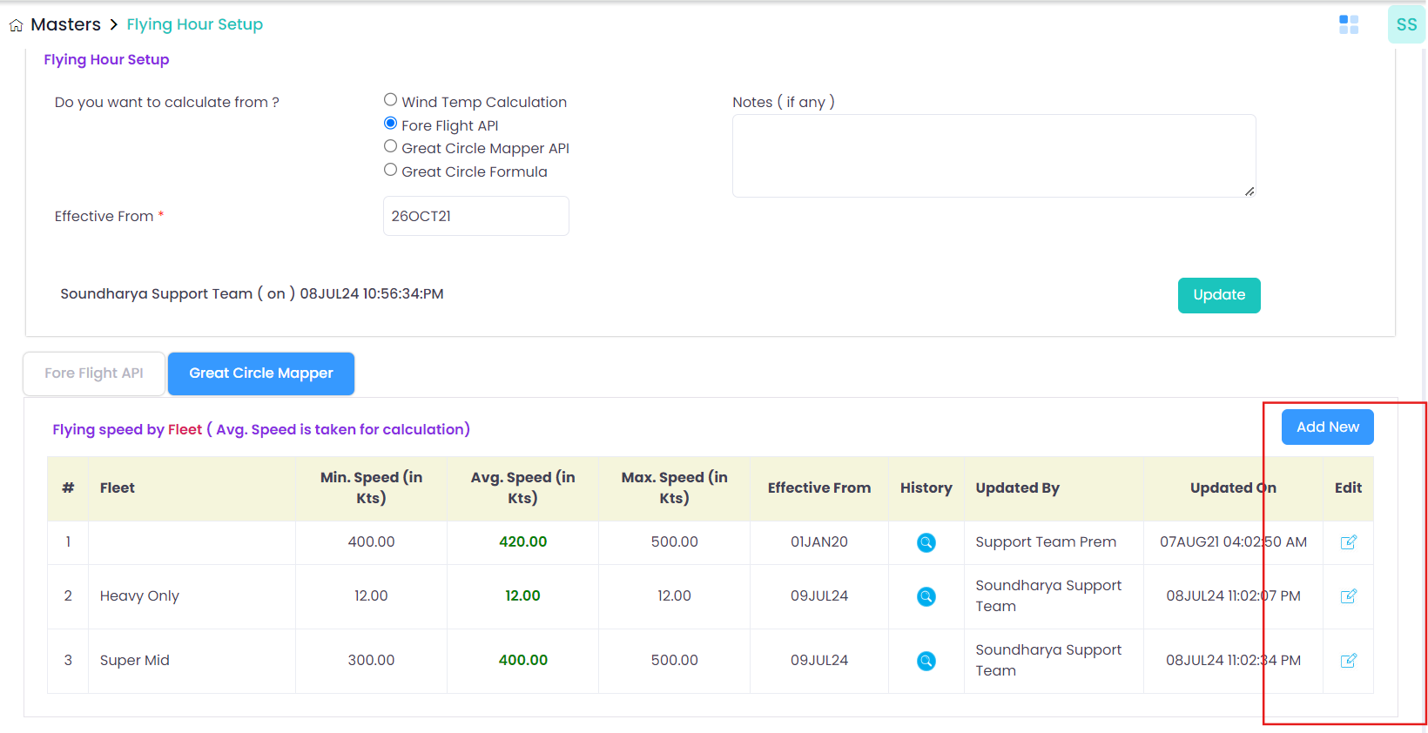

1. Masters-Airport setup-Add new-Without enter any value in airport details and click save button, mandatory alert message is not displayed.
2. Reports-User Report-Search functionn is not working. When enter valid user name with valid from and to date, table shows “No data found”.
3. Reports-Event log report- there is two wind temp tabs in the screen. Need to know the purpose.

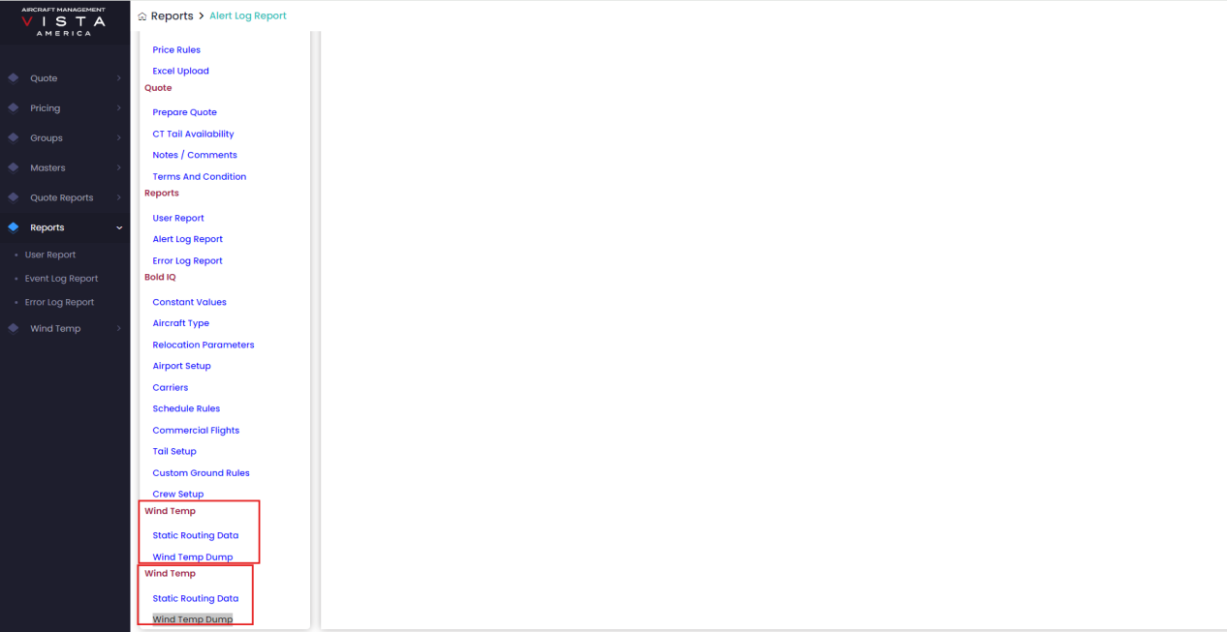

1. Reports-Error log report-When enter valid from date and to date and valid status and click search button, unwanted alert message is displayed
2. Reports-Error log report-After select valid date, click Flying hour setup unwanted alert message is displayed.

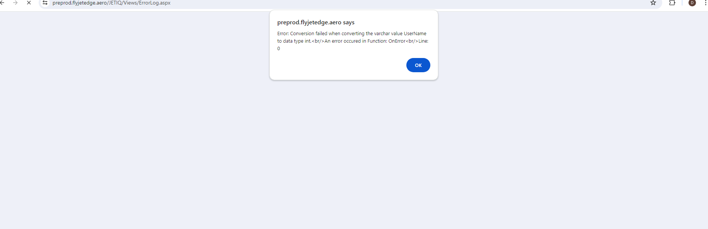

1. In Quote portal, Need to change the background coz cannot easily able find the text box. Need to change the background colours

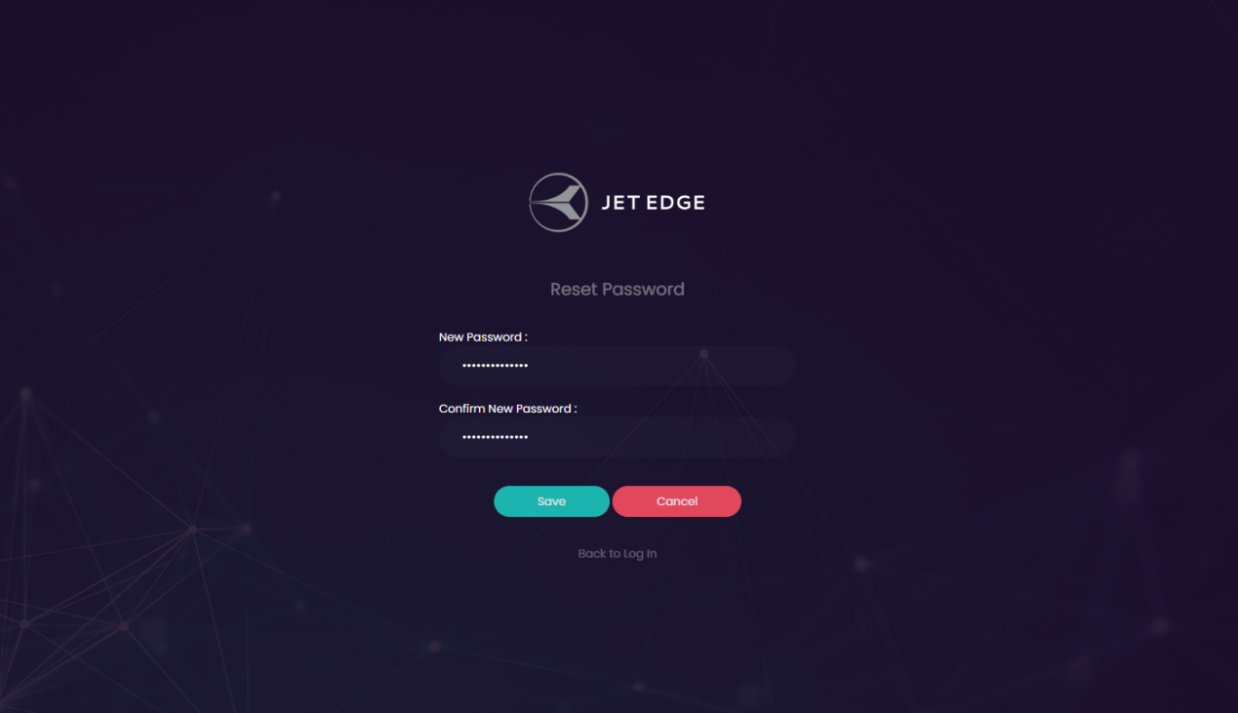

1. In Quote list, Once select valid from date and valid data and click search button, View symbol is moved away from the table

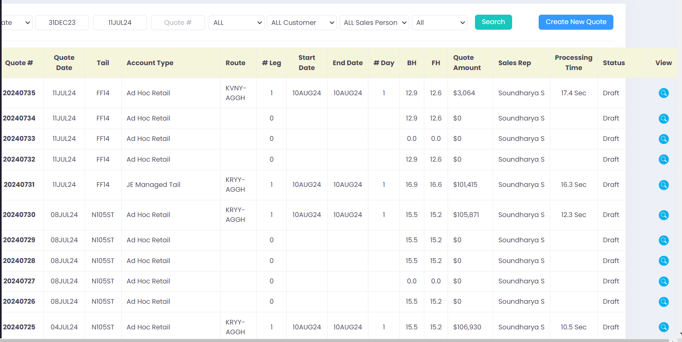

33.In Quote portal, without entering password and click sign in, page goes forward